# Specification document

**Project Name:** **Sporty Shoes**

**Introduction:**

This project is to develop a prototype application for sporty shoes online website.

**Vision/ Mission:** The vision / mission of this project is to digitize and optimize the online shoe buying application called Sporty_shoes.com..

**Technology used:**

* Eclipse/STS
* Java Programming language
* Thymeleaf
* Spring Boot
* Spring MVC Model
* Spring Data JPA
* GitHub
* Scrum
* Maven
* MYSQL
* JDBC

**Requirements:**

* + Admin Welcome Screen with the following Functionalities:

**Change Password Functionality:**

The Admin should be provided option to change password if required.

**Search Users Functionality:**

The Admin should be able to see all users and able to search for users based on whether the users are signed up.

**Mange Products Functionality:**

The Admin should be able to manage products such as

1. Add New Product
2. Edit Product
3. Delete Product

**Generate Purchase Report Functionality:**

The Admin should be able to generate purchase report filtered by Purchase Date and Product Category.

**Flowchart:**

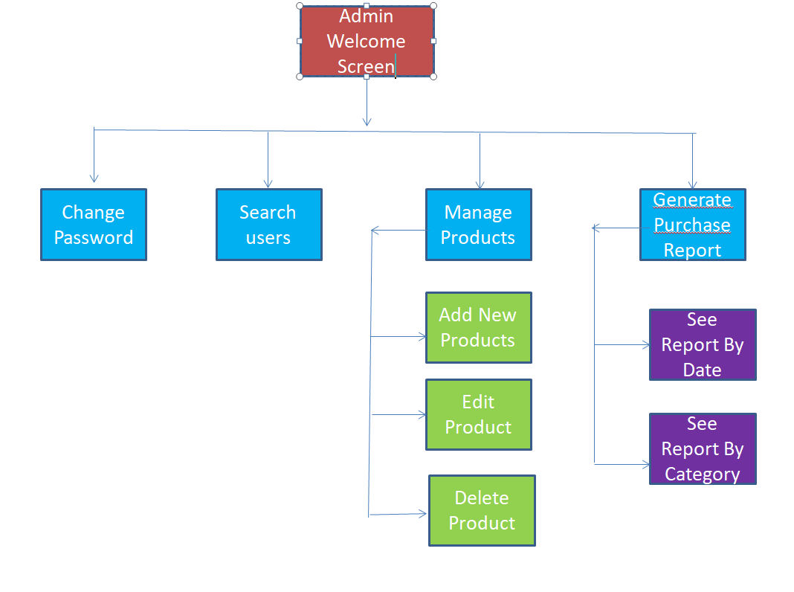

**Databases:**

**user Table:**

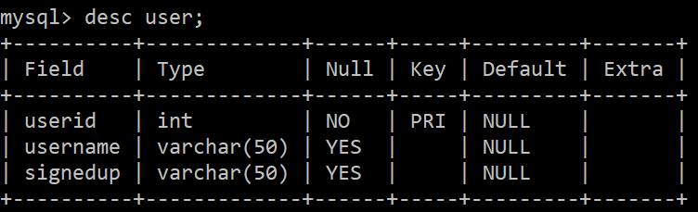

**product Table:**

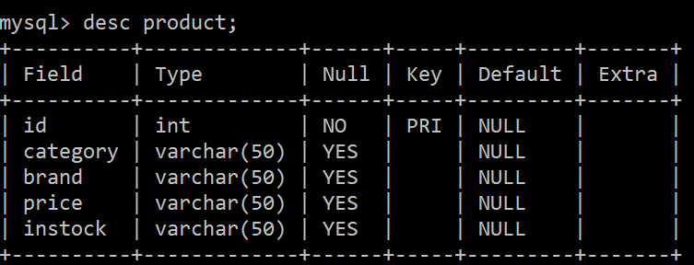

**Purchasereport Table:**

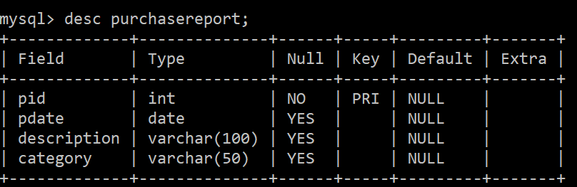

**admin Table:**

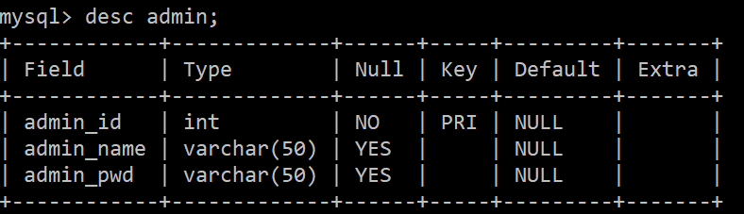

# SportyShoes.com

|  |  |  |  |  |  |  |  |  |
| --- | --- | --- | --- | --- | --- | --- | --- | --- |
| **User Story 1:**  Welcome Screen with Project Name and links to the functionalities . | | | | | | | | |
| Tasks | Estimated Time | | | | Story Points | | | |
| Design and implement a user friendly ,  Welcome message with the project name. Display the hyperlinks to the following functionalities, such as   * Change Password * Search Users * Manage Products * Purchase Report   Keep appearance clean and keep details precise. | 1 hour | | | | 5 | | | |
| **User Story 2:**  Create an Admin database and provide form to change password. | | | | | | | | |
| Tasks | | Estimated Time | | | | Story Points | | |
| * Design the Database with Admin table. * Create a Change password form. * Deliver Password Changed Successfully message. * Create Repository * Create the Service layer * Create the controller | | 3 hr | | | | 8pts. | | |
| **User Story 3:**  Implement Manage Product form. | | | | | | | | |
| Tasks | | | Estimated Time | | | | Story Points | |
| 1. Create a product table in MySQL database. 2. Design the manage product form to display all the available products from the database. 3. Provide the following options in the manage product page and implement the code to these functionalities.  * To Add New Product to database * To Edit Product in database. * To delete a product in database. | | | 15 hours | | | | | 10 pts |
| **User Story 4:**  Design and implement the Purchase Report functionalities. | | | | | | | | |
| Tasks | | | | Estimated Time | | Story Points | | |
| Design and implement the following Purchase Report functionalities.   * Design and implement a purchase report page to view all the purchase report from database. * Provide filters to view purchase report based on date and based on category. | | | | 10 hour | | 10points | | |